Vyskan
Product Name | 4G LTE Waterproof Wide-Voltage Fleet Tracker
Product Model | VF06
Wide-Voltage. Waterproof. Absolute-Control.
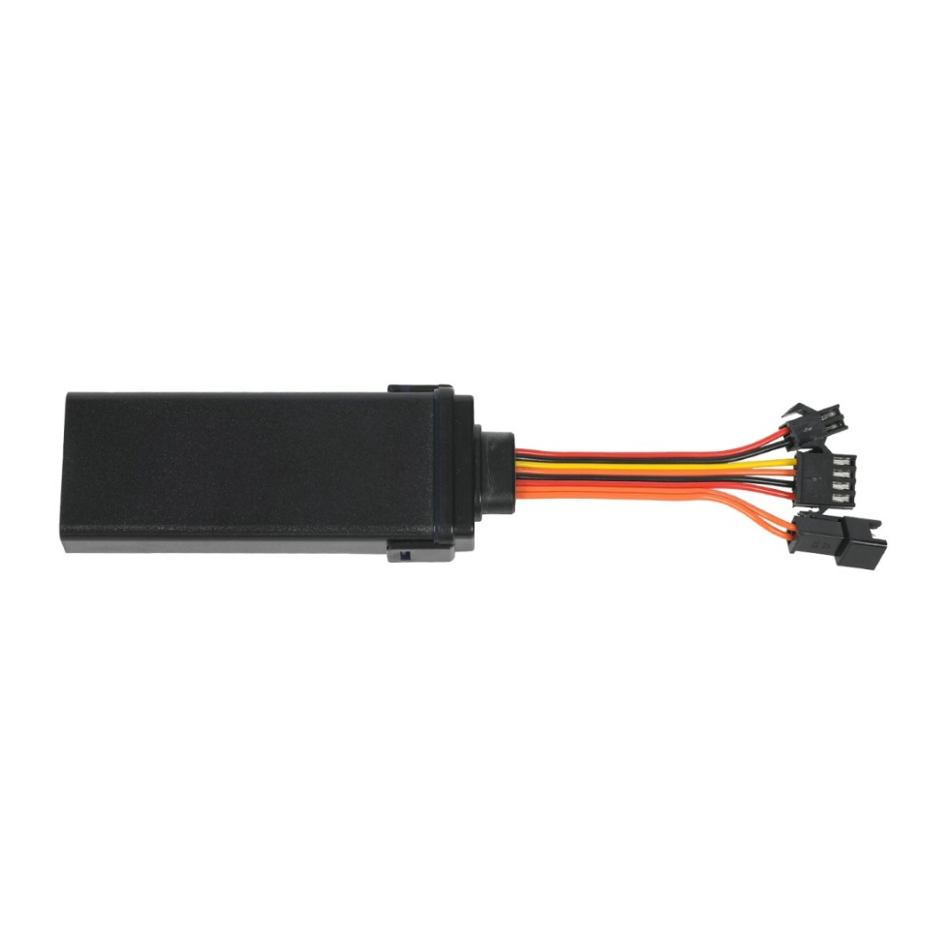
Engineered for harsh outdoor environments and enterprise fleet telematics, the Vyskan VF06 is an industrial-grade IP68 waterproof hardwired 4G LTE tracker operating on a massive 9V-90V voltage range. Integrating GPS/BDS dual-constellation positioning with ACC ignition detection and a remote fuel/power cut-off relay, it offers uncompromising vehicle control even in extreme weather conditions. Compact yet indestructible, it features a 3-axis accelerometer, offline data caching, and multiple alarm triggers (including power-cut and SOS), making it the ultimate security solution for heavy machinery, exposed assets, and global rental fleets.
- Core Value
- Extreme IP68 Waterproof Durability:
Fully sealed to achieve an IP68 rating, this device thrives in heavy rain, mud, or extreme marine environments. This eliminates hardware failure caused by water ingress, drastically saving replacement costs for assets exposed to the elements.
- 9V-90V Ultra-Wide Voltage Adaptability:
The massive DC 9V-90V operating range safely accommodates everything from e-bikes and standard sedans to heavy-duty industrial trucks. This prevents voltage spike burnouts and allows distributors to unify their hardware inventory with a single, universally compatible device.
- Aggressive Remote Immobilization:
Equipped with a dedicated relay control output, fleet managers can instantly cut off the vehicle's fuel or power remotely via the platform in the event of theft, actively neutralizing unauthorized movement.
- Target Applications
- Heavy Machinery & Outdoor Equipment:
The IP68 waterproof rating and 9V-90V input easily handle exposed outdoor environments and the high-power electrical systems of excavators and tractors safely.
- Auto Finance & Car Rental:
Remote fuel cut-off and instant power disconnection alarms offer aggressive, proactive anti-theft countermeasures for high-risk leased vehicles.
- Enterprise Fleet & Logistics:
Precise ACC ignition detection and offline data compensation provide continuous, accurate oversight of engine idle times and true driving routes
- Technical Specifications
3.1 Cellular & GNSS
Category | Specification | Description
Network Bands | 4G LTE-FDD & 2G GSM | Network Bands 4G LTE-FDD & 2G GSM Comprehensive coverage (LTE: B1/B2/B3/B4/B5/B7/B8/B28/B66; GSM: 850/900/1800/1900MHz) for seamless cross-border roaming.
Positioning Mode | BDS + GPS | Dual-constellation tracking ensures highly accurate visibility via an internal anti-interference ceramic antenna.
Startup Time | Cold: Avg 32s | Hot: Avg 1s | Rapid Time-To-First-Fix (TTFF) supported by AGPS for instant location acquisition.
Sensitivity | Tracking: -162 dBm | Maintains a strong satellite lock under challenging environmental conditions.

3.2 Power & Electrical
Category | Specification | Description
Operating Voltage | DC 9V - 90V | Industrial-grade wide voltage architecture preventing high-voltage burnout across mixed fleets.
Working Current | Avg 35mA / Avg 10mA @ 12V | Smart ACC-triggered sleep mechanism significantly lowers average power consumption during idle periods.
Backup Battery | 60 mAh (3.7V Polymer) | Optional internal battery triggers an instant platform alarm (within 3 seconds) if the main vehicle power is maliciously disconnected.
3.3 Interfaces & Expandability
Category | Specification | Description
Vehicle Control | Relay Control Line | Low-output line enabling remote fuel and power cut-off for instant theft neutralization.
Ignition Detection | ACC Input | Accurately monitors vehicle start/stop status to toggle reporting intervals (e.g., 20s moving / 5m stationary).
Alarm Inputs | SOS & Door Sensor | Optional external inputs for emergency panic buttons or physical door tampering detection.
3.4 Physical & Environmental
Category | Specification | Description
Dimensions | 79mm × 33mm × 16mm | Ultra-compact design easily hidden behind dashboards or within fuse boxes.
Weight | 40g | Extremely lightweight yet durable ABS plastic construction
Protection Rating | IP68 | Fully dustproof and waterproof, ensuring maximum reliability against the elements
Operating Temp. | -20℃ to 75℃ | Robust resilience in diverse and extreme climates.
4. Deployment & Integration Covert Hardwiring & Seamless API Integration:
The VF06’s ultra-compact 79x33x16mm footprint allows for deep, covert hardwired installation within a vehicle's electrical system, while its IP68 rating guarantees survival even if installed externally on chassis or motorcycles. It utilizes standard TCP/IP data transmission over domain or IP address connections, allowing frictionless API integration into existing ERP, telematics, or auto finance SaaS dashboards. Fully supporting Over-The-Air (OTA) remote parameter adjustments, administrators can configure speed limit thresholds, draw virtual geofences, and execute remote engine cut-offs from the cloud without ever physically accessing the hardware..
- A personalized service prepared for you
- 1× VA10-Max Sample Device (Pre-configured)
- Full API & Protocol Documentation
- 1-on-1 Technical Support from our Field Engineers
Website: https://vyskan.com/
Email: marketing@vyskan.com

